|  |
| --- |
|  |
| Capstone Project Document |

SUPER SHIPPER SYSTEM

Database Design

|  |  |  |
| --- | --- | --- |
| **Super Shipper System** | | |
| **Group Members** | Le Van Quy Hoang | SE90184 |
| Tran Dinh Hoang Huy | SE90201 |
| Nguyen Khac Hoang | SE02564 |
| Kieu Cao Khanh | SE02960 |
| Nguyen Van Quyen | SE02884 |
| Nguyen Thi Hong Nhung | SE02437 |
| **Supervisor** | Mr. Tran Binh Duong | |
| **Project code** | 3S | |

**- Hanoi, 09/2015 -**

TABLE OF CONTENTS

1. INTRODUCTION 3

1.1. Purpose 3

1.2. Definitions, Acronyms, Abbreviations 3

1.3. Overview 3

2. DATABASE 4

# INTRODUCTION

## 1.1. Purpose

This document contains database design and its details so it will make the developer get to know specifically about the database system components. Beside it, the tester implement the unit test base on this design document.

## 1.2. Definitions, Acronyms, Abbreviations

| Definition | Description | Note |
| --- | --- | --- |
| P/F Key | Primary/ Foreign key | Use to indicate that a field is a primary or foreign key in table: P: Primary key,  F: foreign key, PK: primary key & foreign key |
|  |  |  |

## 1.3. Overview

This document is a detail description of the database design of Super Shipper system. It describes all tables to be created, information stored in each tables, and the relationship between tables.

# DATABASE

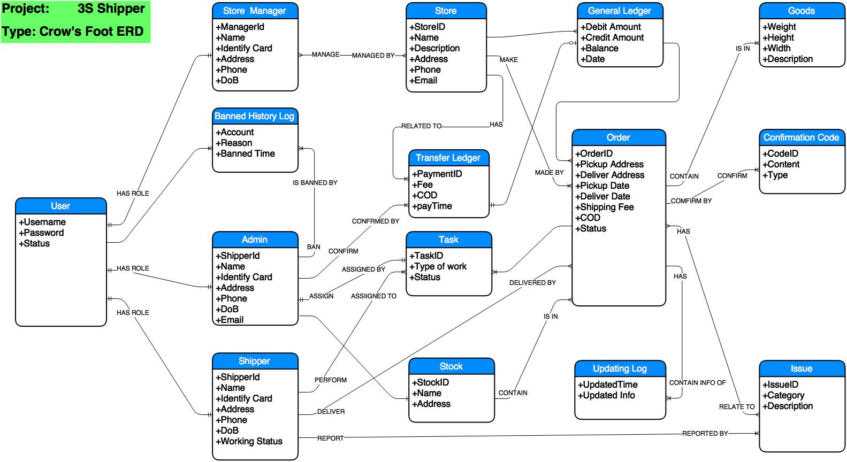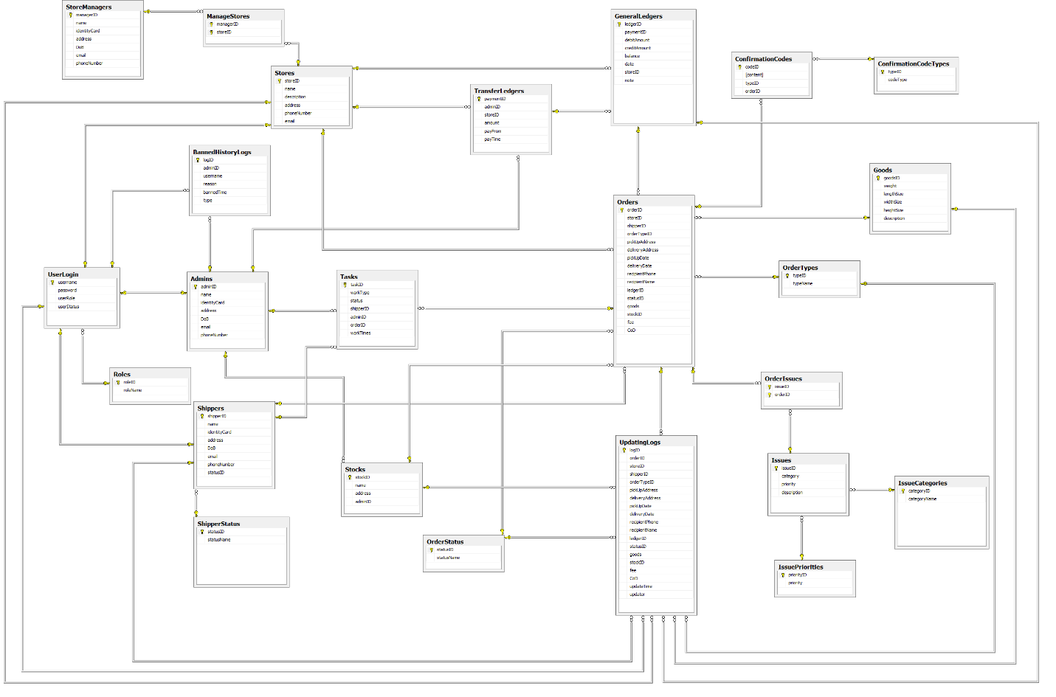

|  |  |  |
| --- | --- | --- |
| **No** | **Table** | **Description** |
|  | UserLogin | Store usernames with password, roles and status of username |
|  | Roles | Store roles in system |
|  | StoreManagers | Store store’s managers and their detailed information |
|  | ManageStores | Store store’s managers and stores which they manage |
|  | Stores | Store stores and it’s detailed information |
|  | BannedHistoryLogs | Store logs about history of banning account |
|  | Admins | Store admins and admin’s detailed information |
|  | Shippers | Store shippers and shipper’s detailed information |
|  | ShipperStatus | Store shipper statuses of work |
|  | Stocks | Store stocks and it’s detailed information |
|  | Tasks | Store tasks for Shipper with detailed information |
|  | TransferLedgers | Store payment and it’s detailed information |
|  | GeneralLedgers | Store balance of the store after each payment and detailed information |
|  | OrderStatus | Store statuses of order |
|  | ConfimationCodes | Store confirmation code for orders and it’s detailed information |
|  | ConfirmationCodeTypes | Store types of confirmation code |
|  | Goods | Store goods and it’s detailed information |
|  | OrderTypes | Store types of order |
|  | Orders | Store orders and it’s detailed information |
|  | OrderIssues | Store issues of specific order and it’s detailed information |
|  | Issues | Store issue’s detailed information |
|  | IssuePriorities | Store issue’s priorities of issue |
|  | IssueCategories | Store issue’s category of issue |
|  | UpdatingLogs | Store logs of updating history |

* **UserLogin table**

|  |  |  |  |  |  |  |  |  |
| --- | --- | --- | --- | --- | --- | --- | --- | --- |
| **No** | **Field name** | **Type** | **Length** | **Allow Null** | **Unique** | **P/F Key** | **Auto increment** | **Description** |
| 1 | username | VARCHAR | 8 | No | x | P |  | unique username for each user |
| 2 | password | VARCHAR | 255 | No |  |  |  | Password of username in MD5 format |
| 3 | userRole | INT |  | No |  | F |  | roleID of username |
| 4 | userStatus | INT |  | No |  | F |  | statusID of username |
| 5 | Token | VARCHAR | 255 | No |  |  |  | Token of user |

* **Roles table**

|  |  |  |  |  |  |  |  |  |
| --- | --- | --- | --- | --- | --- | --- | --- | --- |
| **No** | **Field name** | **Type** | **Length** | **Allow Null** | **Unique** | **P/F Key** | **Auto increment** | **Description** |
| 1 | roleID | INT |  | No | x | P | x | Unique id of role |
| 2 | roleName | VARCHAR | 255 | No |  |  |  | Role’s name |

* **StoreManagers table**

|  |  |  |  |  |  |  |  |  |
| --- | --- | --- | --- | --- | --- | --- | --- | --- |
| **No** | **Field name** | **Type** | **Length** | **Allow Null** | **Unique** | **P/F Key** | **Auto increment** | **Description** |
| 1 | managerID | VARCHAR | 8 | No | x | P |  | Unique id of manager |
| 2 | name | VARCHAR | 50 | No |  |  |  | Manager’s name |
| 3 | identityCard | VARCHAR | 10 | No | x |  |  | Identity Card |
| 4 | address | VARCHAR | 100 | No |  |  |  | Address |
| 5 | DoB | DATE |  | No |  |  |  | Date of birth |
| 6 | email | VARCHAR | 50 | No | x |  |  | Email |
| 7 | phoneNumber | VARCHAR | 11 | No |  |  |  | Phone number |

* **ManageStores table**

|  |  |  |  |  |  |  |  |  |
| --- | --- | --- | --- | --- | --- | --- | --- | --- |
| **No** | **Field name** | **Type** | **Length** | **Allow Null** | **Unique** | **P/F Key** | **Auto increment** | **Description** |
| 1 | managerID | VARCHAR | 8 | No | x | PF |  | Unique id of manager |
| 2 | storeID | VARCHAR | 50 | No | x | PF |  | Unique id of store |

* **Stores table**

|  |  |  |  |  |  |  |  |  |
| --- | --- | --- | --- | --- | --- | --- | --- | --- |
| **No** | **Field name** | **Type** | **Length** | **Allow Null** | **Unique** | **P/F Key** | **Auto increment** | **Description** |
|  | storeID | VARCHAR | 8 | No | x | P |  | Unique id of store |
|  | name | VARCHAR | 50 | No |  |  |  | Store’s name |
|  | description | TEXT |  | No |  |  |  | Description about store |
|  | address | VARCHAR | 100 | No |  |  |  | Address |
|  | email | VARCHAR | 50 | No | x |  |  | Email |
|  | phoneNumber | VARCHAR | 11 | No |  |  |  | Phone number |

* **BannedHistoryLogs table**

|  |  |  |  |  |  |  |  |  |
| --- | --- | --- | --- | --- | --- | --- | --- | --- |
| **No** | **Field name** | **Type** | **Length** | **Allow Null** | **Unique** | **P/F Key** | **Auto increment** | **Description** |
|  | logID | INT |  | No | x | P | x | Unique id of log |
|  | adminID | VARCHAR | 8 | No |  | F |  | Id of admin |
|  | username | VARCHAR | 8 | No |  | F |  | Username is banned |
|  | reason | TEXT |  | No |  |  |  | Reason of ban |
|  | bannedTime | DATE |  | No |  |  |  | Time of ban |
|  | type | VARCHAR | 5 | No |  |  |  | Types of ban: ban or unban |

* **Admins table**

|  |  |  |  |  |  |  |  |  |
| --- | --- | --- | --- | --- | --- | --- | --- | --- |
| **No** | **Field name** | **Type** | **Length** | **Allow Null** | **Unique** | **P/F Key** | **Auto increment** | **Description** |
| 1. 1 | adminID | VARCHAR | 8 | No | x | P |  | Unique id of admin |
| 1. 2 | name | VARCHAR | 50 | No |  |  |  | Admin’s name |
| 1. 3 | identityCard | VARCHAR | 10 | No | x |  |  | Identity Card |
| 1. 4 | address | VARCHAR | 100 | No |  |  |  | Address |
| 1. 5 | DoB | DATE |  | No |  |  |  | Date of birth |
| 1. 6 | email | VARCHAR | 50 | No | x |  |  | Email |

* **Shippers table**

|  |  |  |  |  |  |  |  |  |
| --- | --- | --- | --- | --- | --- | --- | --- | --- |
| **No** | **Field name** | **Type** | **Length** | **Allow Null** | **Unique** | **P/F Key** | **Auto increment** | **Description** |
| 1. 1 | shipperID | VARCHAR | 8 | No | x | P |  | Unique id of admin |
| 1. 2 | name | VARCHAR | 50 | No |  |  |  | Admin’s name |
| 1. 3 | identityCard | VARCHAR | 10 | No | x |  |  | Identity Card |
| 1. 4 | address | VARCHAR | 100 | No |  |  |  | Address |
| 1. 5 | DoB | DATE |  | No |  |  |  | Date of birth |
| 1. 6 | email | VARCHAR | 50 | No | x |  |  | Email |
| 1. 7 | statusID | INT |  | No |  | F |  | Id of shipper’s working status |

* **ShipperStatus table**

|  |  |  |  |  |  |  |  |  |
| --- | --- | --- | --- | --- | --- | --- | --- | --- |
| **No** | **Field name** | **Type** | **Length** | **Allow Null** | **Unique** | **P/F Key** | **Auto increment** | **Description** |
| 1. 1 | statusID | INT |  | No | x | P | x | Unique id of status |
| 1. 2 | statusName | VARCHAR | 20 | No |  |  |  | Working status: available, busy,… |

* **Stocks table**

|  |  |  |  |  |  |  |  |  |
| --- | --- | --- | --- | --- | --- | --- | --- | --- |
| **No** | **Field name** | **Type** | **Length** | **Allow Null** | **Unique** | **P/F Key** | **Auto increment** | **Description** |
| 1. 1 | stockID | INT |  | No | x | P | x | Unique id of stock |
| 1. 2 | name | VARCHAR | 50 | No |  |  |  | Stock’s name |
| 1. 4 | address | VARCHAR | 100 | No |  |  |  | Address |
| 1. 5 | adminID | VARCHAR | 8 | No |  | F |  | ID of admin who manages the stock |

* **Task table**

|  |  |  |  |  |  |  |  |  |
| --- | --- | --- | --- | --- | --- | --- | --- | --- |
| **No** | **Field name** | **Type** | **Length** | **Allow Null** | **Unique** | **P/F Key** | **Auto increment** | **Description** |
| 1. 1 | taskID | INT |  | No | x | P | x | Unique id of stock |
| 1. 2 | workType | VARCHAR | 20 | No |  |  |  | Type of work: gather, deliver |
| 1. 3 | status | VARCHAR | 20 | No |  |  |  | Status of work: normal or express |
| 1. 4 | adminID | VARCHAR | 8 | No |  | F |  | ID of admin who assigns this task |
|  | shipperID | VARCHAR | 8 | No |  | F |  | ID of shipper who does this task |
|  | orderID | VARCHAR | 8 | No |  | F |  | ID of order |
|  | workTimes | INT |  | No |  |  |  | The time of this order |

* **TransferLedgers table**

|  |  |  |  |  |  |  |  |  |
| --- | --- | --- | --- | --- | --- | --- | --- | --- |
| **No** | **Field name** | **Type** | **Length** | **Allow Null** | **Unique** | **P/F Key** | **Auto increment** | **Description** |
| 1. 1 | paymentID | INT |  | No | x | P | x | Unique id of payment |
| 1. 2 | adminID | VARCHAR | 8 | No |  | F |  | ID of admin who confirms this payment |
| 1. 3 | storeID | VARCHAR | 8 | No |  | F |  | ID of store who sends or receives payment |
| 1. 4 | Amout | BIGINT |  | No |  |  |  | Amount of payment |
|  | payFrom | INT |  | No |  |  |  | If value is 0, the store sends payment to system.  If value is 1, the system sends payment for store |
|  | payTime | DATETIME |  | No |  |  |  | ID of order |

* **GeneralLedgers table**

|  |  |  |  |  |  |  |  |  |
| --- | --- | --- | --- | --- | --- | --- | --- | --- |
| **No** | **Field name** | **Type** | **Length** | **Allow Null** | **Unique** | **P/F Key** | **Auto increment** | **Description** |
| 1. 1 | ledgerID | INT |  | No | x | P | x | Unique id of ledger |
| 1. 2 | paymentID | INT |  | No |  | F |  | ID of payment |
| 1. 3 | storeID | VARCHAR | 8 | No |  | F |  | ID of store who sends or receives payment |
| 1. 4 | debitAmount | BIGINT |  | No |  |  |  | Amount of debit |
|  | creditAmount | BIGINT |  | No |  |  |  | Amount of credit |
|  | balance | BIGINT |  | No |  |  |  | Balance after payment |
|  | date | DATETIME |  | No |  |  |  | Date of this ledger |
|  | note | TEXT |  | Yes |  |  |  | Note |

* **ConfirmationCodeTypes table**

|  |  |  |  |  |  |  |  |  |
| --- | --- | --- | --- | --- | --- | --- | --- | --- |
| **No** | **Field name** | **Type** | **Length** | **Allow Null** | **Unique** | **P/F Key** | **Auto increment** | **Description** |
| 1. 1 | typeID | INT |  | No | x | P | x | Unique id of code type |
| 1. 2 | codeType | VARCHAR | 20 | No |  |  |  | Type of code: Get order, delivery order,… |

* **ConfirmationCodes table**

|  |  |  |  |  |  |  |  |  |
| --- | --- | --- | --- | --- | --- | --- | --- | --- |
| **No** | **Field name** | **Type** | **Length** | **Allow Null** | **Unique** | **P/F Key** | **Auto increment** | **Description** |
| 1. 1 | codeID | INT |  | No | x | P | x | Unique id of confirmation code |
| 1. 2 | typeID | INT |  | No |  | F |  | ID of code type |
| 1. 3 | orderID | VARCHAR | 8 | No |  | F |  | ID of order |
| 1. 4 | codeContent | INT |  | No |  |  |  | Content of code |

* **Goods table**

|  |  |  |  |  |  |  |  |  |
| --- | --- | --- | --- | --- | --- | --- | --- | --- |
| **No** | **Field name** | **Type** | **Length** | **Allow Null** | **Unique** | **P/F Key** | **Auto increment** | **Description** |
| 1. 1 | goodsID | INT |  | No | x | P | x | Unique id of goods |
| 1. 2 | weight | FLOAT |  | No |  | F |  | Weight of goods |
| 1. 3 | lengthSize | FLOAT |  | No |  | F |  | lengthSize of goods |
| 1. 4 | widthSize | FLOAT |  | No |  |  |  | widthSize of goods |
|  | heightSize | FLOAT |  | No |  |  |  | heightSize of goods |
|  | description | TEXT |  | No |  |  |  | description of goods |

* **OrderTypes table**

|  |  |  |  |  |  |  |  |  |
| --- | --- | --- | --- | --- | --- | --- | --- | --- |
| **No** | **Field name** | **Type** | **Length** | **Allow Null** | **Unique** | **P/F Key** | **Auto increment** | **Description** |
| 1. 1 | typeID | INT |  | No | x | P | x | ID of order’s type |
| 1. 2 | typeName | VARCHAR | 20 | No |  |  |  | Name of type: normal, express,… |

* **OrderStatus table**

|  |  |  |  |  |  |  |  |  |
| --- | --- | --- | --- | --- | --- | --- | --- | --- |
| **No** | **Field name** | **Type** | **Length** | **Allow Null** | **Unique** | **P/F Key** | **Auto increment** | **Description** |
| 1. 1 | statusID | INT |  | No | x | P | x | ID of order’s status |
| 1. 2 | statusName | VARCHAR | 20 | No |  |  |  | Name of order’s status: gathering, delivering,… |

* **Orders table**

|  |  |  |  |  |  |  |  |  |
| --- | --- | --- | --- | --- | --- | --- | --- | --- |
| **No** | **Field name** | **Type** | **Length** | **Allow Null** | **Unique** | **P/F Key** | **Auto increment** | **Description** |
| 1. 1 | orderID | INT |  | No | x | P | x | Unique id of orders |
| 1. 2 | storeID | VARCHAR | 8 | No |  | F |  | ID of store |
| 1. 3 | shipperID | VARCHAR | 8 | No |  | F |  | ID of shipper who ships orders |
| 1. 4 | orderTypeID | INT |  | No |  | F |  | typeID of orders |
|  | pickUpAddress | VARCHAR | 100 | No |  |  |  | Address for picking up order |
|  | deliveryAddress | VARCHAR | 100 | No |  |  |  | Address for delivering up order |
|  | pickUpDate | DATE |  | No |  |  |  | Date of picking up order |
|  | deliveryDate | DATE |  | Yes |  |  |  | Date of delivering order |
|  | recipientPhone | VARCHAR | 11 | Yes |  |  |  | Phone of recipient |
|  | recipientName | VARCHAR | 50 | Yes |  |  |  | Recipient’s Name |
|  | ledgerID | INT |  | Yes |  | F |  | LedgerID of order |
|  | statusID | INT |  | No |  | F |  | statusID of order |
|  | goods | INT |  | No |  | F |  | goodsID of order |
|  | stockID | INT |  | Yes |  | F |  | stockID of order |
|  | fee | BIGINT |  | No |  |  |  | Fee of order |
|  | CoD | BIGINT |  | Yes |  |  |  | Cash on delivery |

* **IssuePriorities table**

|  |  |  |  |  |  |  |  |  |
| --- | --- | --- | --- | --- | --- | --- | --- | --- |
| **No** | **Field name** | **Type** | **Length** | **Allow Null** | **Unique** | **P/F Key** | **Auto increment** | **Description** |
| 1. 1 | priorityID | INT |  | No | x | P | x | ID of priority |
| 1. 2 | priority | VARCHAR | 20 | No |  |  |  | Priority of issue: high, medium... |

* **IssueCategories table**

|  |  |  |  |  |  |  |  |  |
| --- | --- | --- | --- | --- | --- | --- | --- | --- |
| **No** | **Field name** | **Type** | **Length** | **Allow Null** | **Unique** | **P/F Key** | **Auto increment** | **Description** |
| 1. 1 | categoryID | INT |  | No | x | P | x | ID of category |
| 1. 2 | categoryName | VARCHAR | 20 | No |  |  |  | Category of issue: Accident, Disconnection, .. |

* **Issues table**

|  |  |  |  |  |  |  |  |  |
| --- | --- | --- | --- | --- | --- | --- | --- | --- |
| **No** | **Field name** | **Type** | **Length** | **Allow Null** | **Unique** | **P/F Key** | **Auto increment** | **Description** |
| 1. 1 | issueID | INT |  | No | x | P | x | ID of issue |
| 1. 2 | category | INT |  | No |  | F |  | categoryID of issue |
|  | priority | INT |  | No |  | F |  | priorityID of issue |
|  | description | TEXT |  | No |  |  |  | Description |

* **OrderIssues table**

|  |  |  |  |  |  |  |  |  |
| --- | --- | --- | --- | --- | --- | --- | --- | --- |
| **No** | **Field name** | **Type** | **Length** | **Allow Null** | **Unique** | **P/F Key** | **Auto increment** | **Description** |
| 1. 1 | issueID | INT |  | No |  | PF |  | ID of issue |
| 1. 2 | orderID | INT |  | No |  | PF |  | ID of order which has issues |

* **UpdatingLogs table**

|  |  |  |  |  |  |  |  |  |
| --- | --- | --- | --- | --- | --- | --- | --- | --- |
| **No** | **Field name** | **Type** | **Length** | **Allow Null** | **Unique** | **P/F Key** | **Auto increment** | **Description** |
| 1. 1 | orderID | INT |  | No | x | P | x | Unique id of orders |
| 1. 2 | storeID | VARCHAR | 8 | No |  | F |  | ID of store |
| 1. 3 | shipperID | VARCHAR | 8 | No |  | F |  | ID of shipper who ships orders |
| 1. 4 | orderTypeID | INT |  | No |  | F |  | typeID of orders |
|  | pickUpAddress | VARCHAR | 100 | No |  |  |  | Address for picking up order |
|  | deliveryAddress | VARCHAR | 100 | No |  |  |  | Address for delivering up order |
|  | pickUpDate | DATE |  | No |  |  |  | Date of picking up order |
|  | deliveryDate | DATE |  | Yes |  |  |  | Date of delivering order |
|  | recipientPhone | VARCHAR | 11 | Yes |  |  |  | Phone of recipient |
|  | recipientName | VARCHAR | 50 | Yes |  |  |  | Recipient’s Name |
|  | ledgerID | INT |  | Yes |  | F |  | LedgerID of order |
|  | statusID | INT |  | No |  | F |  | statusID of order |
|  | goods | INT |  | No |  | F |  | goodsID of order |
|  | stockID | INT |  | Yes |  | F |  | stockID of order |
|  | fee | BIGINT |  | No |  |  |  | Fee of order |
|  | CoD | BIGINT |  | Yes |  |  |  | Cash on delivery |
|  | updateTime | DATETIME |  | No |  |  |  | Time of updating |
|  | Updater | VARCHAR | 8 | No |  | F |  | Username of updater |